**DAV HZL SR. SEC. SCHOOL, DARIBA**

**TENTATIVE CO-CURRICULAR ACTIVITIES 2024-25**

|  |  |  |
| --- | --- | --- |
| **Date** | **Class** | **Activity (Event)** |
| 06/04/2024 | III TO V | Cinematic Odyssey: Arya Samaj Chronicles |
| VI TO VIII | Narrative Alchemy: Crafting English Tales |
| IX TO XII | Lens Enchantment: Interclass Cinematic Journey |
| 20/04/2024 | III TO V | Soliloquy Symphony: Mastering English Monologues |
| VI TO VIII | Dramatic Flourish: Theatrical Skits in English |
| IX TO XII | Electoral Insights: Interclass PowerPoint Showdown |
| 04/05/2024 | III TO V | Artistry Unleashed: Collage Creation Extravaganza |
| VI TO VIII | Sculpting Stories: From Clay to Chronicle |
| IX TO XI | Pixel Perfection: Design Delights with Photoshop |
| 05/07/2024 | III TO VIII | Green Horizon: Plantation Expedition |
| 06/07/2024 | III TO V | Calligraphy |
| VI TO X | Echoes of Ecology: English Environmental Orations |
| 11/07/2024 | III TO XII | Leadership Unveiled: Investiture Spectacular |
| 20/07/2024 | III TO V | Lexical Showdown: Spellbinding Spell Bee |
| VI TO VII | Verbal Voyage: Vocabulary Ventures |
| IX TO XI | Enlightening Discourse: TED Talk Showdown |
| 03/08/2024 | III TO V | Culinary Chronicles: Fireside Cooking & Artistry |
| VI TO IX | Taste Temptations: Culinary Competition |
| 17/08/2024 | III TO VIII | Cultural Kaleidoscope: Rangoli, Rakhi& Arya Samaj Quizzes |
| 31/08/2024 | III TO V | Social Science Showdown: Quiz Quest |
| VII TO X | Parliamentary Prowess: Youth Debate Showdown |
| 06/09/2024 | III TO V | Hindi Heritage: Crafting Original Stories & Poems |
| VI TO VII | Hindi Heritage: Crafting Original Poems |
| VIII TO X | Declamatory Divinity: Hindi Oratory Odyssey |
| 05/10/2024 | III TO V | Blogosphere Brilliance: Crafting Digital Chronicles |
| VI TO VII | Wall Wonders: Mural Masterpieces |
| VIII | Wonders on earthen plates |
| 19/10/2024 | III TO V | Moral Mosaic: Hindi Skits on Values |
| VI TO IX | Theatrical Tribute: Great Personality Dramatizations |
| 08/11/2024 | III TO V | Melodic Medley: Songster Showdown |
| VI TO IX | Devotional Delights: Bhajan Bliss |
| 23/11/2024` | III TO V | Innovation Illuminated: Inventors' Showcase |
| VI TO VII | Journey of a Dreamer;Biography |
| VIII TO IX Sci. | Scientific Sorcery: Enchanting Science Magic |
| 07/12/2024 | III TO V | Literary Legacy: Bookmark Bonanza |
| VI TO VIII | Informative Imprints: Brochure Brilliance |
| 21/12/2024 | III TO IX | Math Marvels: Exploring Fun & Practical Mathematics |
| 18/01/2025 | III TO VII | Patriotic Penmanship: Slogan Sketching & Doodling |
| 31/01/2025 | III TO V | Resourceful Innovation: Waste Material Wonders & Presentations |

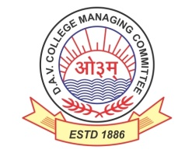

DAV HZL Sr. Sec. School dariba

rajsamand (raj.)

DAV HZL Sr. Sec. School dariba, rajsamand(raj.)

Split-up Syllabus

Class- III

Split-up Syllabus & Activities

for the session

2024-25

Class-XI (Science)

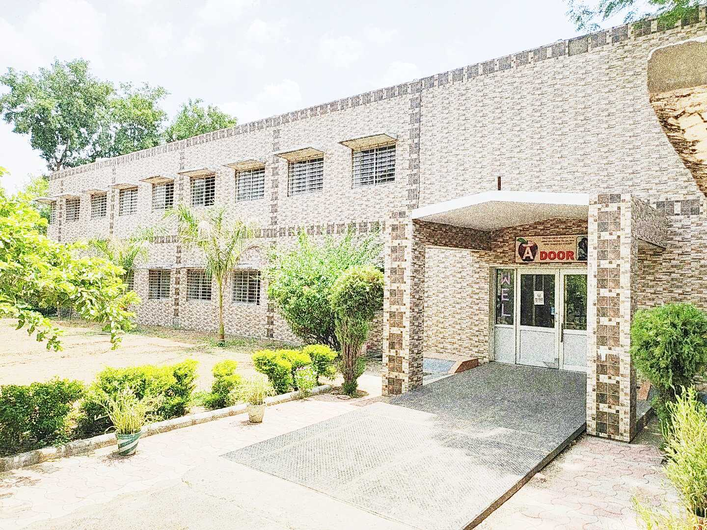

Address : Rajpura-Dariba, Distt. – Rajsamand (Raj.) 313211

Contact : (02952)265130 Email : davhzl_dariba@yahoo.com Website : www.davhzldariba.in

|  |  |  |
| --- | --- | --- |
| **Subject** | **UT- I** | **UT - II** |
| **English** | The Portrait of lady  A Photograph  Note Making / summary | We are not afraid to Die, Laburnum Top, Tenses, Transformation of Sentences, Classifieds |
| **Physics** | Ch.-1,2,3, | Ch.-4,5 |
| **Chemistry** | Classification of elements and periodicity in properties , Redox reaction | Some basic concept of chemistry , Structure of Atom |
| **Maths** | Ch. –2,3 | Ch. 4,5,7 |
| **Biology** | Ch – 1,2 | Ch –5,6 |
| **Physical Education** | Ch – 1 & 2 | Ch – 3 & 4 |

|  |  |
| --- | --- |
| **Subject** | **Mid Term** |
| **English** | We are not afraid to die, The Address, Discovering Tut, The Laburnum Top, The Summers of Beautiful White Horse, Tenses Transformation of sentences / Classifieds |
| **Physics** | Unit and Dimension, motion in straight line & motion in a plane, law of motion, work, power & energy,Center of Mass and Rotation motion |
| **Chemistry** | Classification of elements and periodicity in properties, Redox reactions, Structure of atom, Some basic concepts of chemistry, Chemical Thermodynamics |
| **Maths** | Ch. – 1 to 8 |
| **Biology** | Ch– 1 to 7 |
| **Physical Education** | Ch - 1, 2, 3, 4, 5 |

|  |  |
| --- | --- |
| **Subject** | **Final Term** |
| **English** | Complete course as per DAV Board |
| **Physics** | Complete course as per DAV Board |
| **Chemistry** | Complete course as per DAV Board |
| **Mathematics** | Complete course as per DAV Board |
| **Biology** | Complete course as per DAV Board |
| **Physical Education** | Complete course as per DAV Board |

|  |  |
| --- | --- |
| **Exam** | **TENTATIVE DATES OF EXAM** |
| **UT – I** | First Week of May 2024 |
| **UT- II** | First Week of August 2024 |
| **MID – TERM** | Third Week of September 2024 |
| **Pre-Board-I** | Second Week Of December 2024 |
| **Pre-Board -II** | January 2025 |
| **FINAL TERM** | Last Week of Feb.2025 |